Operation and Assembly Manual

Remote Operated Excavator Arm

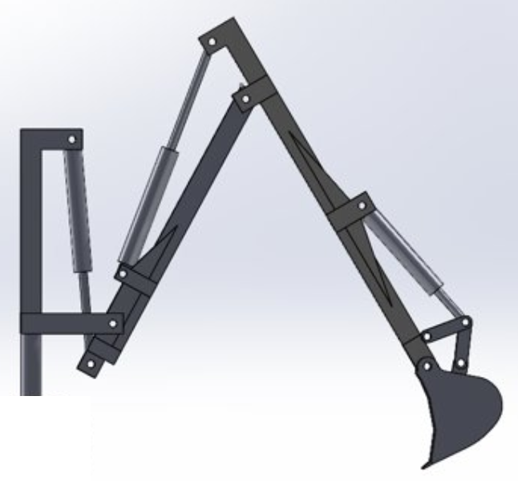

Materials

* 1 ½ inch x 15 in PVC pipe (x2)
* 1 ½ inch x 14 in PVC pipe (x1)
* 1 ½ inch x 4 1/2 in PVC pipe (x1)
* 1 ½ inch x 13 inch PVC pipe (x1)
* 1 ½ inch x 5 inch PVC pipe cut (x1)
* 1 ½ inch x 4 inch PVC pipe cut (x1)
* 1 inch x 11 ½ inch PVC pipe (x2)
* 3/4 inch x 11 ½ inch PVC pipe (x2)
* 3x2 inch x 30 inch Wooden beam (x2)
* 3x2 inch x 6 inch Wooden beam with ½ inch hole (x2)
* 3x2 inch x 6 inch Wooden beam with 3/8 inch hole (x2)
* 3x2 inch x 5 1/2 inch Wooden beam (x1)
* 3x2 inch x 15 inch Wooden beam cut 45 degree ends (x1)
* 1 ½ inch PVC T fitting (x3)
* 1 ½ inch PVC 90 degree elbow fitting (x1)
* 6 inch stroke hydraulic RAM (x1)
* 1/4 inch x 4 inch carriage bolt (x6)
* 1/4 inch x 2 1/2 inch carriage bolt (x1)
* 3/8 inch x 8 inch carriage bolt (x2)
* ½ inch x 6-inch bolt (x1)
* ¼ inch nut (x7)
* 3/8 inch nut (x4)
* ½ inch nut (x1)
* ¼ inch washer (x8)
* 3/8 washer (x3)
* 15 inch aluminum fencing brackets (x1)
* 9 inch aluminum fencing bracket (x4)
* ¾ inch x 7 inch x 11 ½ inch wood board (x2)
* ¾ inch x 7 inch x 28 inch wood board (x1)
* 1 ¼ inch steel cap with 3/8-inch hole (x1)
* 3/8 x 6 inch eye bolt (x1)
* 3/8 inch lock washer (x2)
* 2 inch multi-purpose construction screws (x25)
* 1 ¼ multi-purpose construction screws (x6)
* 6 x 7 x 10 inch 3D printed bucket (x1)
* 1 hp electric motor (x1)
* Hydraulic tank (x1)
* 6 ft of ½ inch 4000 psi hydraulic hose (x2)
* 2 ft of ½ inch 4000 psi hydraulic hose (x2)
* Bi-directional hydraulic solenoid (x1)
* 3 liters of hydraulic fluid

Tools

* Crescent wrench
* Phillips head screw driver
* Power drill
* Phillips head bit

CAD

* Tower design
* Boom design
* Dipper design
* Bucket design
* Bucket bracket design
* Full Arm assembly

**Assembly/Disassembly**

The first step of assembly is to identify each of the separate parts and group the common items together. Once the parts are in groups specified by the user, the following steps will walk the user through the full assembly process.

1. Arrange the ¾ inch boards in an + shape with the 28-inch piece in the center.
2. Place one of the 30-inch 3x2 wooden beams horizontally along the + so that the beam is in contact with all three pieces of board and bring the beam to the bottom edge of the smaller boards.
3. Once the beam is aligned, screw 2 of the 2-inch screws into each wooden board going through the beam first. This step will secure the boards together and will act as the supportive base for the arm.
4. After the base is tightly secured and placed flat on the floor, center the second 30-inch wooden beam on the + and butt the edge up to the horizontal beam, and orient the second beam vertically protruding upward, perpendicular to the first beam. Trace the edge of the vertical beam to ensure that the beam stays centered during step 5.
5. While keeping the beam centered on the base, turn the entire assembly upside down, and screw 2 of the 2-inch screws through the base, and into the vertical beam. Once screws are in, flip over again so that the base is flat on the floor and the 30-inch beam is perpendicular to the floor.
6. Next, all 4 of the 6-inch beams will be attached to the vertical beam, called the tower. The horizontal beam will be a reference for the “back” of the tower. Align the 6-inch beams with the ½ inch hole so that they are parallel to the ground, and the edges of the beams are flush with the back and the top of the tower. Before screwing the beams into place, ensure that the 3-inch surface is the surface in contact with the tower. After the orientation is correct, screw 2 of the 2-inch screws through the beams and into the tower, one below the other such as “:”.
7. Step 6 will be repeated with the 3/8-inch hole, however instead of the edge being flush with the top of the tower, the bottom edge of the beam will be 6 inches above the base, while the back edge is still flush with the back edge of the tower.
8. Place hydraulic RAM between the two wooden beams at the top of the tower with the ½ inch holes, such that the piston will extend downward and insert the ½ inch bolt through the wooden beams and the RAM. Once the bolt head is flush with the beam, place the ½ inch nut on the opposite side and secure it with the crescent wrench. Check that the RAM can rotate about the bolt before proceeding to step 9.
9. Screw one of the 3/8-inch nuts about half the length down the 3/8-inch eye bolt and then slide on 1 of the 3/8-inch lock washers. Next, slide the cap down to the washer with the threads of the cap facing away from the eye. Next apply the second lock washer and then screw on a 3/8-inch nut so that the end of the eye bolt is flush with the top edge of the nut. This will ensure that the cap will screw on to the RAM. Once the second nut is flush with the end of the eye bolt, rotate the first nut until it reaches the cap and tighten with the crescent wrench so that the nuts and washers squeeze together with the cap in the middle.
10. After the cap and eye bolt are joined, screw the assembly onto the end of the RAM and once it is tight, ensure that the eye is concentric with the 3/8-inch holes on the lower 6-inch beams.
11. Take one of the 15-inch PVC pipes with a notch cut out at the end and orient the notch facing upward. Place the ¼ inch carriage bolt length of 2 ½ inches through the ¼ inch holes on the side of the notch and through the eye. Screw on one of the ¼ inch nuts to secure the bolt in place.
12. After the eye is attached to the 15-inch pipe, place one of the 3/8-inch carriage bolts through the holes on the wooden beams and the pipe. Once the bolt is through all the components, place a 3/8 washer and nut on the other and secure tightly with the wrench. Test that the pipe segment rotates about the bolt smoothly.
13. If the pipe rotates smoothly, place the 5 ½ inch wooden beam across the top of the tower so that the edges are flush with the back of the tower and the outer edges of the horizontal beams. Screw 2 screws through the beam and into each of the horizontal beams and 1 screw through the beam and into the tower.
14. To further increase stability, place the 15-inch wooden beam with 45-degree edges against the back of the tower and against the base, and screw 2 screws through each end.
15. Place one of the PVC T fittings at the end of the attached pipe and make the single open-end point vertically upward. Place the 4 1/2-inch pipe with cut in the T opening and have the notch opening away from the tower. In the remaining opening of the T fitting, insert the 13-inch pipe segment with the holes on the opposite end.
16. Use the 4-inch pipe with 1 ½ inch diameter to join the 90-degree elbow fitting and a T fitting together. Ensure that the bottom opening of the T fitting and the open end of the elbow are facing the same way.
17. Insert the 14-inch pipe into the opposite end of the T fitting
18. Place the last T fitting at the end of the 14-inch segment with the bottom of the T opening opposite the other T fitting.
19. Place the other 15-inch segment in the open end of the T fitting with the holes at the far end of the T. This will result in the dipper segment with a total length of 36-inches.
20. In the open section of the T fitting further from the elbow, insert the 5-inch pipe with a cut so that the cut faces away from the elbow.
21. Take the 15-inch fencing bracket and place the center on the top edge of the T fitting closest to the elbow and screw the 1 ¼ inch screws through the allocated holes so that the bracket wraps around the T and both edges are extending past the T at an equal length.
22. Line up the larger holes at the end of the bracket with the holes in the pipe at the end of the boom and insert a ¼ inch carriage bolt through all holes with a washer between the bolt head and the bracket. Finally secure the bolt in place with a second 1/4 washer followed by a ¼ inch nut.
23. The 1-inch pipes will slide into the notched pipes protruding from the T fittings and will be secured using a ¼ inch carriage bolt that will go through the notched pipe and the 1-inch pipe and will be fastened down with a ¼ inch washer and finally a ¼ inch bolt.
24. For the boom, slide the ¾ inch pipe inside the 1-inch pipe with the holes remaining outside. The ¾ inch pipe will then be placed inside the opening of the 90-degree elbow and then a ¼ inch carriage bolt will go through the elbow and the ¾ inch pipe and then be secured with a washer and nut.
25. There will be small holes in the end of the dipper with a diameter of 1/8 inch. The 9-inch brackets have pre-allocated holes that have the same diameter. Line up the holes and attach the brackets to the dipper with 1, 1 ¼ inch screw on each bracket. Be sure to have the brackets extending an equal length upward.
26. The bucket will then be attached at the end of the dipper with a 3/8-inch carriage bolt with washers on either side of the bucket and a nut to secure the bucket tightly.
27. The remaining 2 brackets have larger holes at one end, and those holes will match up with a larger hole on the bucket. A ¼ inch carriage bolt with a washer on both sides of the bucket and a nut will secure the brackets to the bucket, and they will also need to be oriented vertically at an equal distance.
28. The remaining ¾ inch pipe will be inserted into the 1-inch pipe on the dipper with the holes remaining outside of the 1-inch pipe.
29. Finally, the holes in the ¾ inch pipe will need to be aligned with the holes on the brackets such that all 6 holes are concentric. A ¼ inch carriage bolt will be inserted through all 6 holes and fastened down with a washer a nut.

**Operation**

1. Plug in the motor power cable along with the solenoid power cable.
2. Turn on computer with Arduino board attached to have access to remote operation
3. Turn on the switch that controls the motor which sends hydraulic fluid from tank to the solenoid
4. Ensure wires are secure and no hydraulic fluid is leaking from any part of the excavator.
5. Next, use the Arduino joystick to operate and control the arm, ensure no interference with the arm and allows free range of motion.
6. The joystick has two ranges of motion in the y direction, pushing the joystick up will make the hydraulic ram retract, pushing the joystick down with allow the hydraulic ram to extend.

**Maintenance**

1. Ensure proper amount of hydraulic fluid is in the hydraulic reservoir.
2. Make sure all cables are attached and in good condition.
3. Ensure that all hydraulic tubes are secured and tight with no leaking
4. Check to see that all joints are properly lubricated, and nothing is interfering with the arm range of motion.
5. Keep out of extreme weather conditions